Experiment: 8
Steering Angle Variation in MIMO Beamforming Using MATLAB
Objective 1:
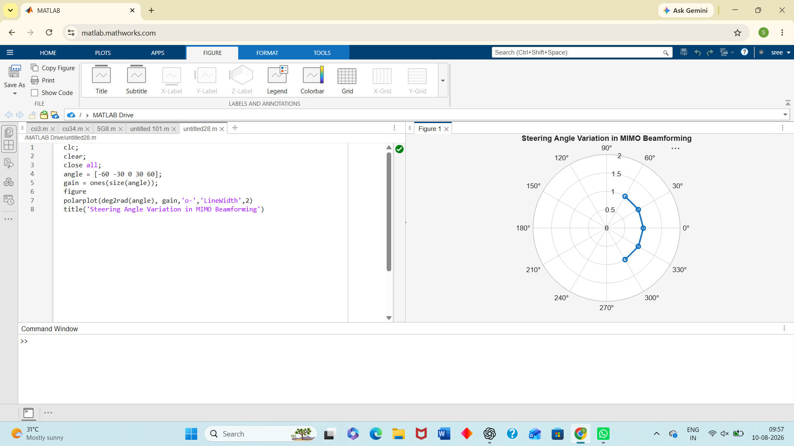
Objective 2:
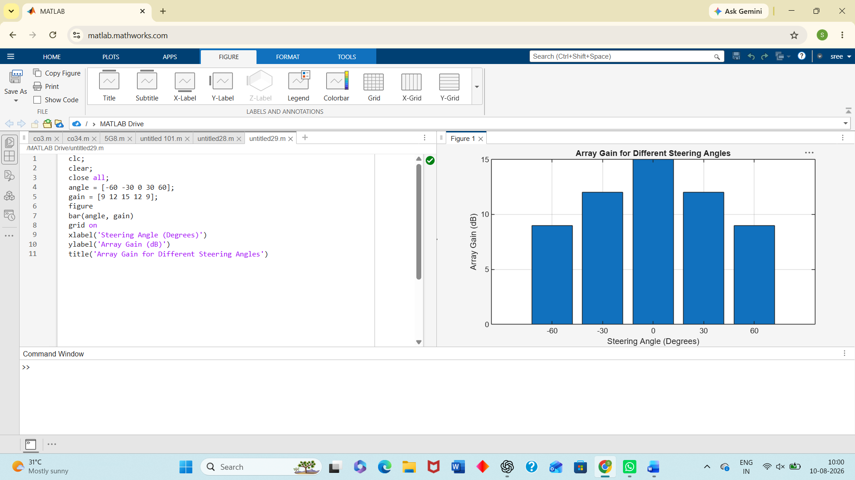
Objective 3:
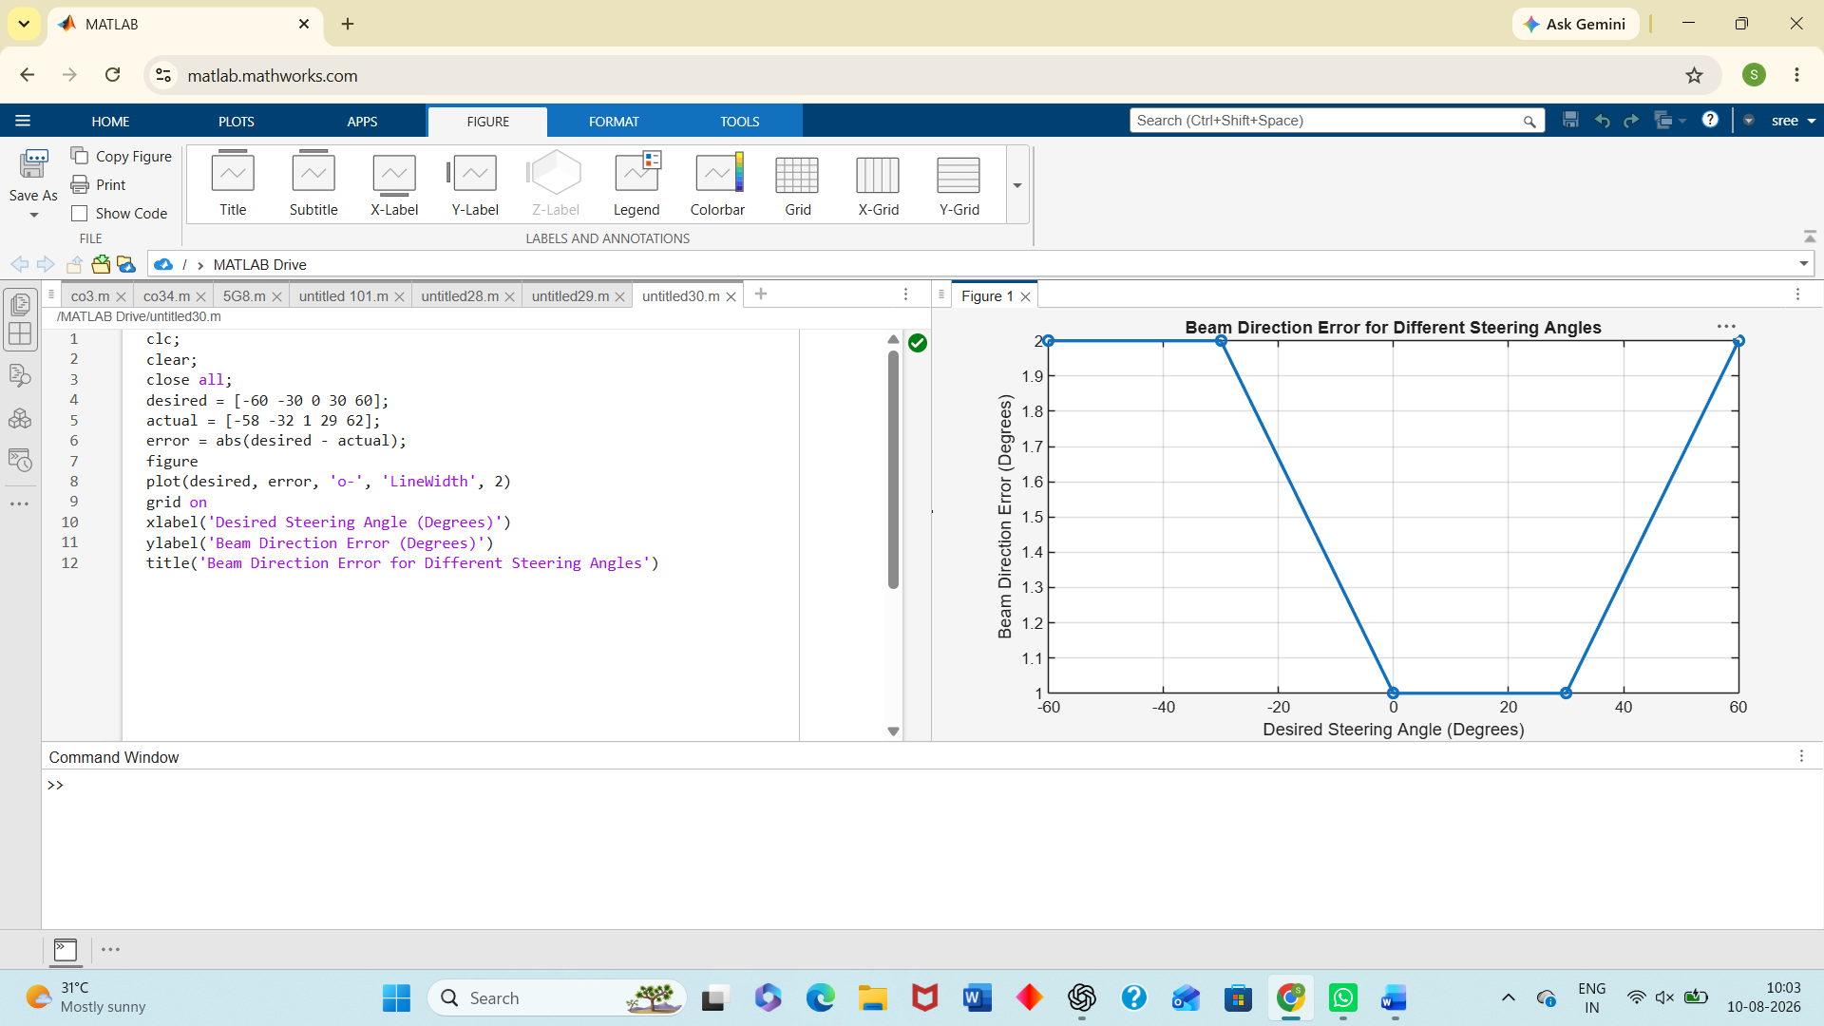
RESULT :
The MATLAB analysis successfully demonstrated steering angle variation in a MIMO beamforming system. The results showed that beam steering effectively directs the transmitted energy toward different angles, while maintaining high array gain and minimizing beam direction error.

